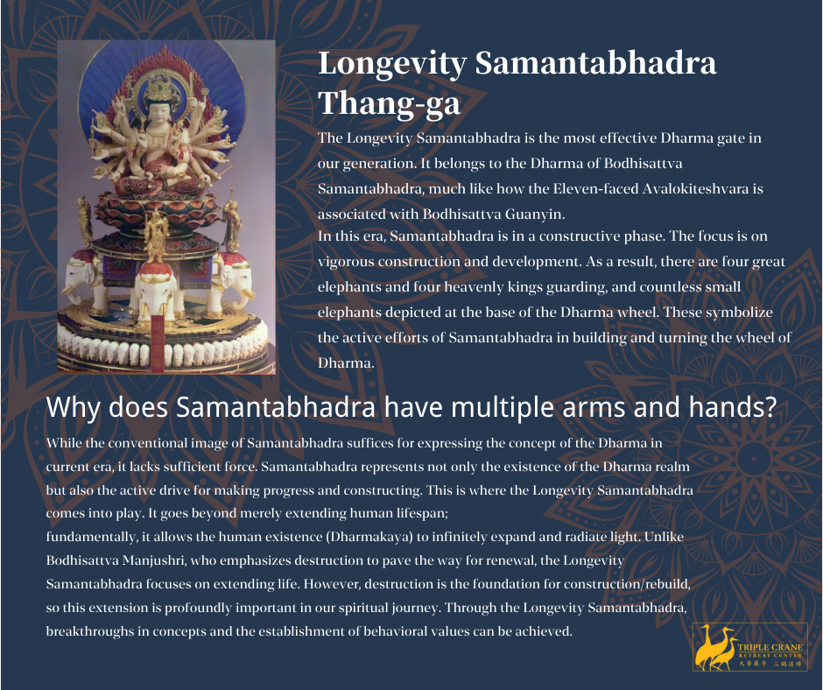

Longevity Samantabhadra Thang-ga:

The Longevity Samantabhadra is the most effective Dharma gate in our generation. It belongs to the Dharma of Bodhisattva Samantabhadra, much like how the Eleven-faced Avalokiteshvara is associated with Bodhisattva Guanyin.

In this era, Samantabhadra is in a constructive phase. The focus is on vigorous construction and development. As a result, there are four great elephants and four heavenly kings guarding, and countless small elephants depicted at the base of the Dharma wheel. These symbolize the active efforts of Samantabhadra in building and turning the wheel of Dharma.

Why does Samantabhadra have multiple arms and hands? While the conventional image of Samantabhadra suffices for expressing the concept of the Dharma in current era, it lacks sufficient force. Samantabhadra represents not only the existence of the Dharma realm but also the active drive for making progress and constructing. This is where the Longevity Samantabhadra comes into play. It goes beyond merely extending human lifespan;

fundamentally, it allows the human existence (Dharmakaya) to infinitely expand and radiate light. Unlike Bodhisattva Manjushri, who emphasizes destruction to pave the way for renewal, the Longevity Samantabhadra focuses on extending life. However, destruction is the foundation for construction/rebuild, so this extension is profoundly important in our spiritual journey. Through the Longevity Samantabhadra, breakthroughs in concepts and the establishment of behavioral values can be achieved.

